**MODEL APPROACH FOR MOOD PREDICTION BASED ON AUDIO FEATURE**

**Context**

This dataset contains audio statistics of the top 2000 tracks on Spotify. Songs released from 1956 to 2019 are included from some notable and famous artists like *Queen*, *The Beatles*, *Guns N' Roses*, etc.  
<http://sortyourmusic.playlistmachinery.com/> by [@plamere](https://www.kaggle.com/plamere) uses Spotify API to extract the audio features from the tracks given the Spotify Playlist URI. This data contains audio features like Danceability, Liveness, Speechiness and many more.  
Each feature's description has been given in detail below.

Content

* Index: ID
* Title: Name of the Track
* Artist: Name of the Artist
* Acoustic: The higher the value the more acoustic or instrumental the song is.
* Danceability: The higher the value, the easier it is to dance to this song.
* Loudness: The higher the value, the louder the song.
* Speechiness: The higher the value the more spoken words the song contains
* Liveness : The higher the value , the more likely the song ia live recording

Acknowledgements

This data is extracted from the Spotify playlist - Top 2000s on PlaylistMachinery(@plamere) using Selenium with Python. More specifically, it was scraped from <http://sortyourmusic.playlistmachinery.com/>. Thanks to Paul for providing a free and open source to extract features and do cool stuff with your Spotify playlists!

Model Building Approach to predict mood based on audio features :-

1. First I have taken 2000 songs track data with following feature that are mentioned in content above .Then I plotted the histogram of each audio feature

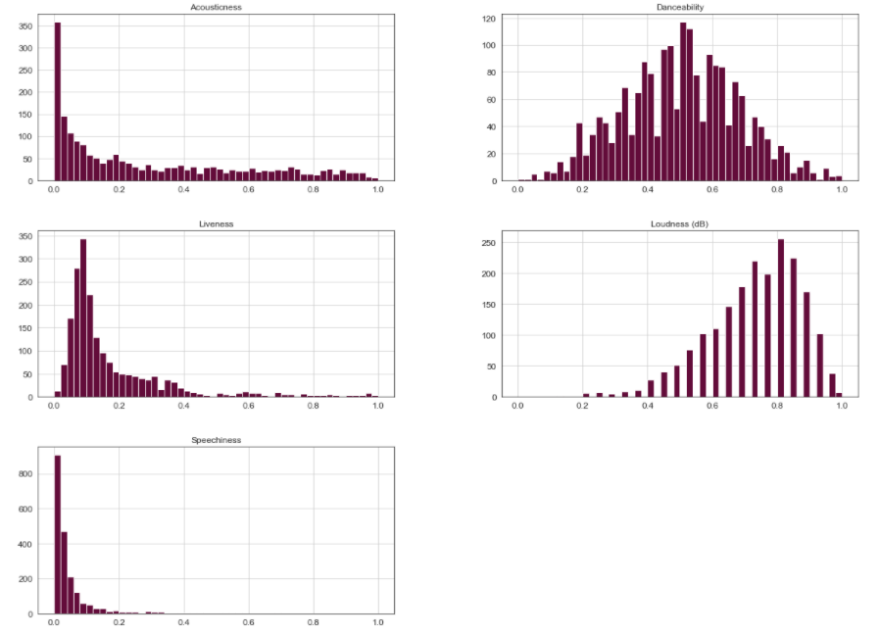

1. Then I Performed k mean clustering to find cluster that have similar audio feature . I got 5 cluster .Basically the visualization of cluster is done by the help of PCA (Principal component analysis ). As we have five audio feature related to each songs . so we cannot visualize them so I have taken first two principal component and with the help of that tried to visualize songs cluster based on audio feature

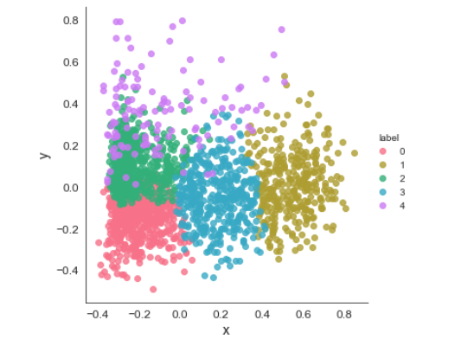

1. I labelled 5 cluster to following mood 'Romantic' ,'Nostalgic' ,'Artsy' ,'Sad' ,'Chill' by analysisng the songs lyrics and listening to song .
2. Now I have feature and a mood associated with each feature . so using the complete data I first splitted the data in training and testing data with 2:1 data ratio respectively and builded model on train data and tested model performance on test data . Basically I used Random forest classifier and Support vector machine algorithm to model the audio feature and mood . below are the confusion matrix and some classification report of two model

For random forest :-

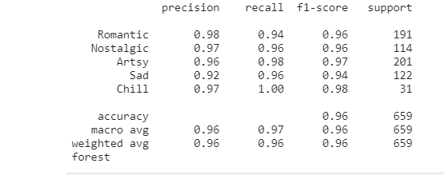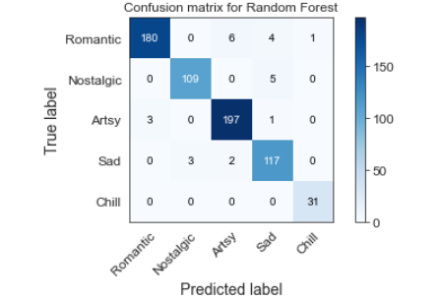

For SVM :-

